

## ****LAB PROJECT REPORT****

## Course Title :

***“CCN”***

***Submitted to: DR. ZARA HAMID***

## Submitted By: NAME: Maham Aftab

***Aimen Baseer***

## CLASS: 3A REG NO: FA15-BSE-019

***Introduction :***

We have created the network of four deparments of Comsats university by connecting 30 PC’S in every department and all PC’S are allocated dynamic IP addresses. All hosts are configures in such a way that every PC can send mail , ping to other hosts.  
***IP Addressing Table :***

|  |  |
| --- | --- |
| *Server-PT DNS* | *11.11.11.1* |
| *Server PT web and email services* | *11.11.11.2* |
| *Network address of EE students* | *192.168.1.0/24* |
| *Server PT DHCP EE students* | *192.168.1.0/24* |
| *Network address of EE faculty* | *192.168.2.0/24* |
| *Server PT DHCP EE faculty* | *192.168.2.2/24* |
| *Network address of physics students* | *192.168.3.0/24* |
| *Server PT DHCP physics students* | *192.168.3.2/24* |
| *Server PT DHCP management students* | *192.168.4.2/24* |
| *Network address of management students* | *192.168.4.0/24* |
| *Server PT DHCP CS students* | *192.168.6.0/24* |
| *Network address of CS students* | *192.168.5.2/24* |

* ***Routers Configurations :***
* ***OSPF :***

*For Physics :*

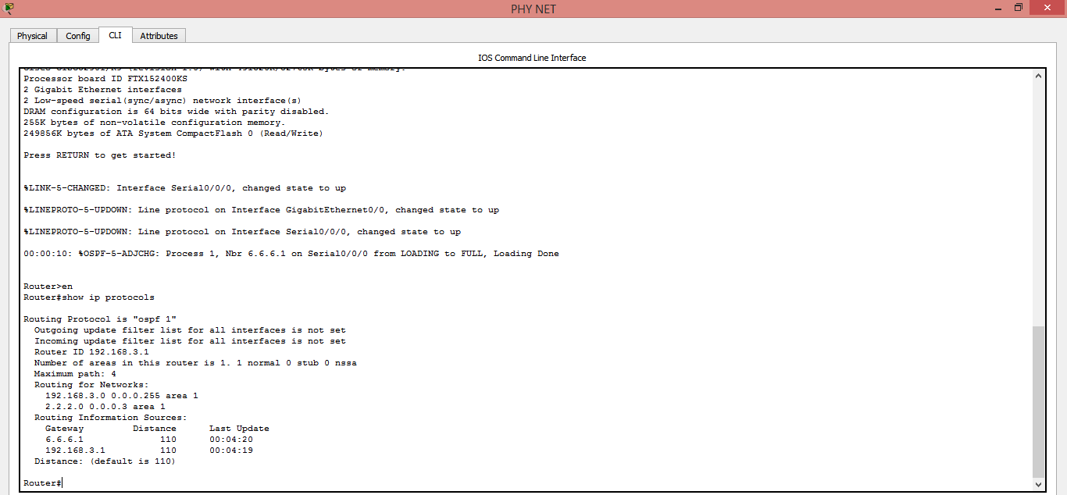

* ***RIP :***

*For EE Students :*

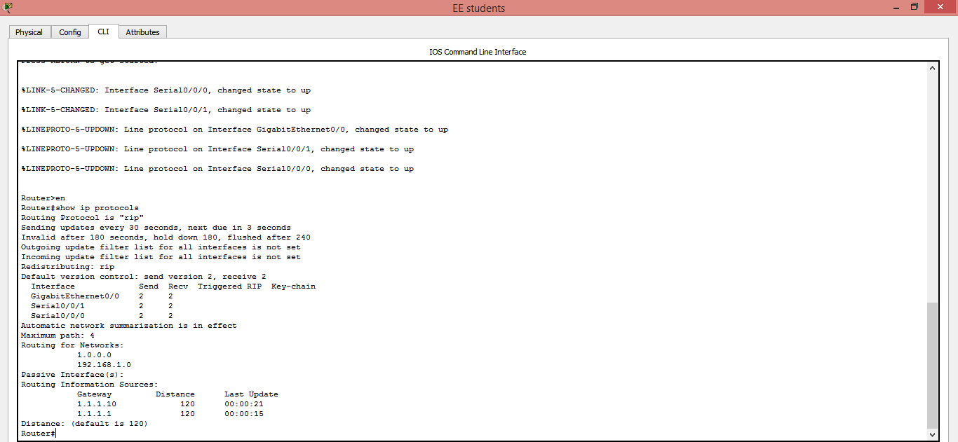

*For EE Faculty :*

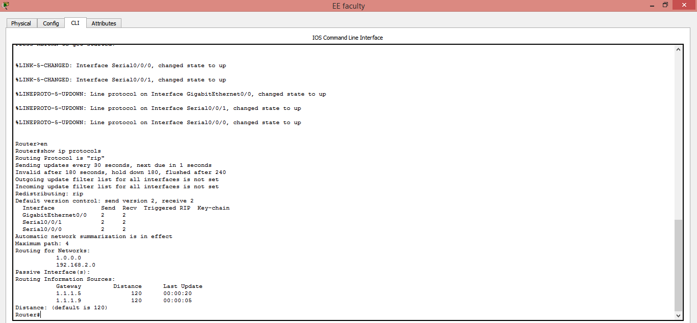

* ***EIGRP :***

*For Management :*

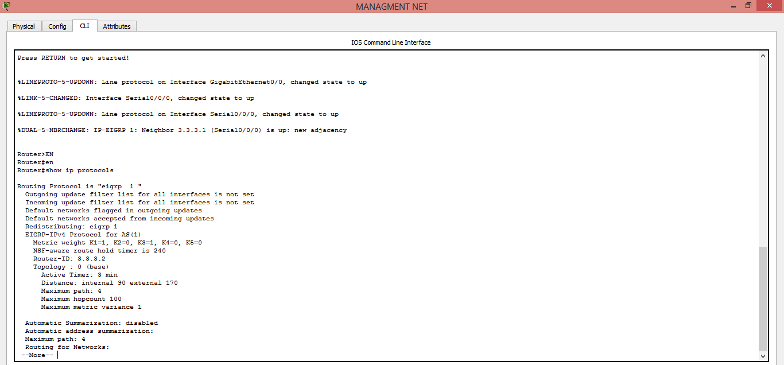

*For CS Students :*

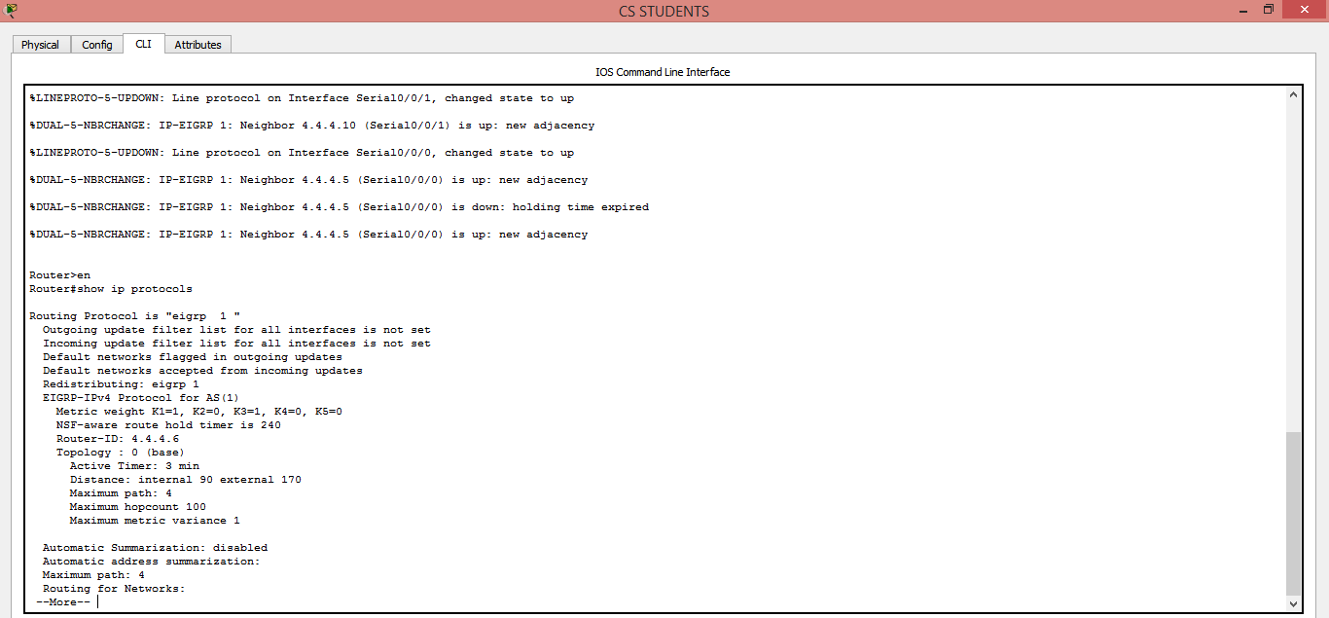

*For CS Faculty :*

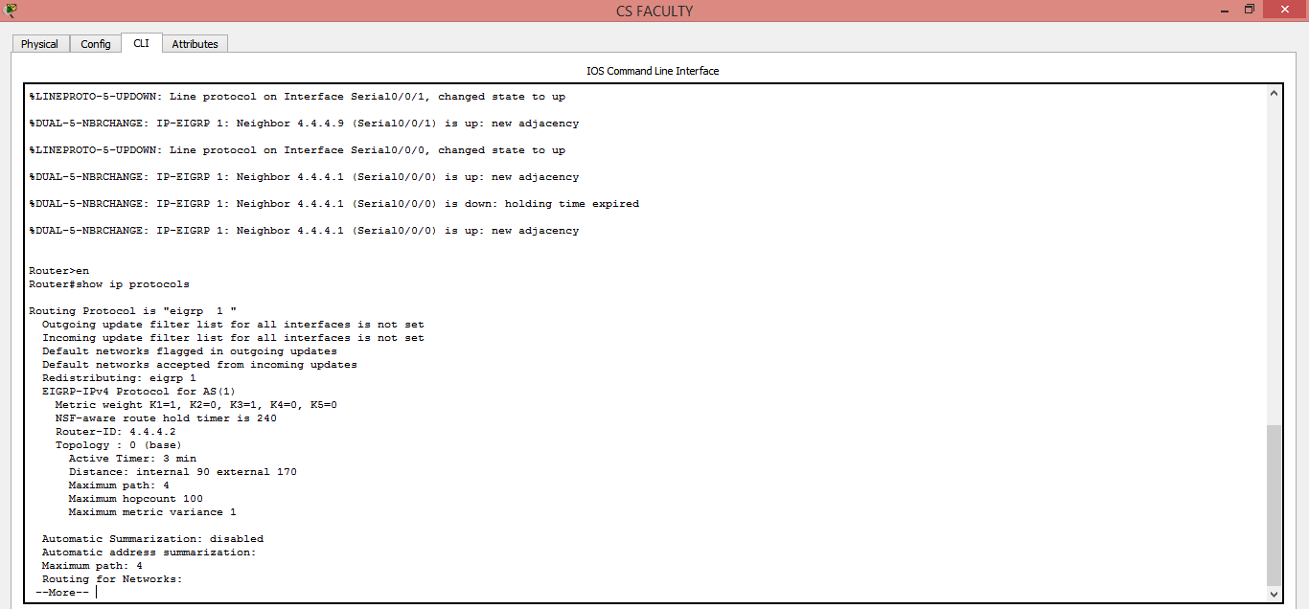

* ***VLAN Configurations Screenshots :***

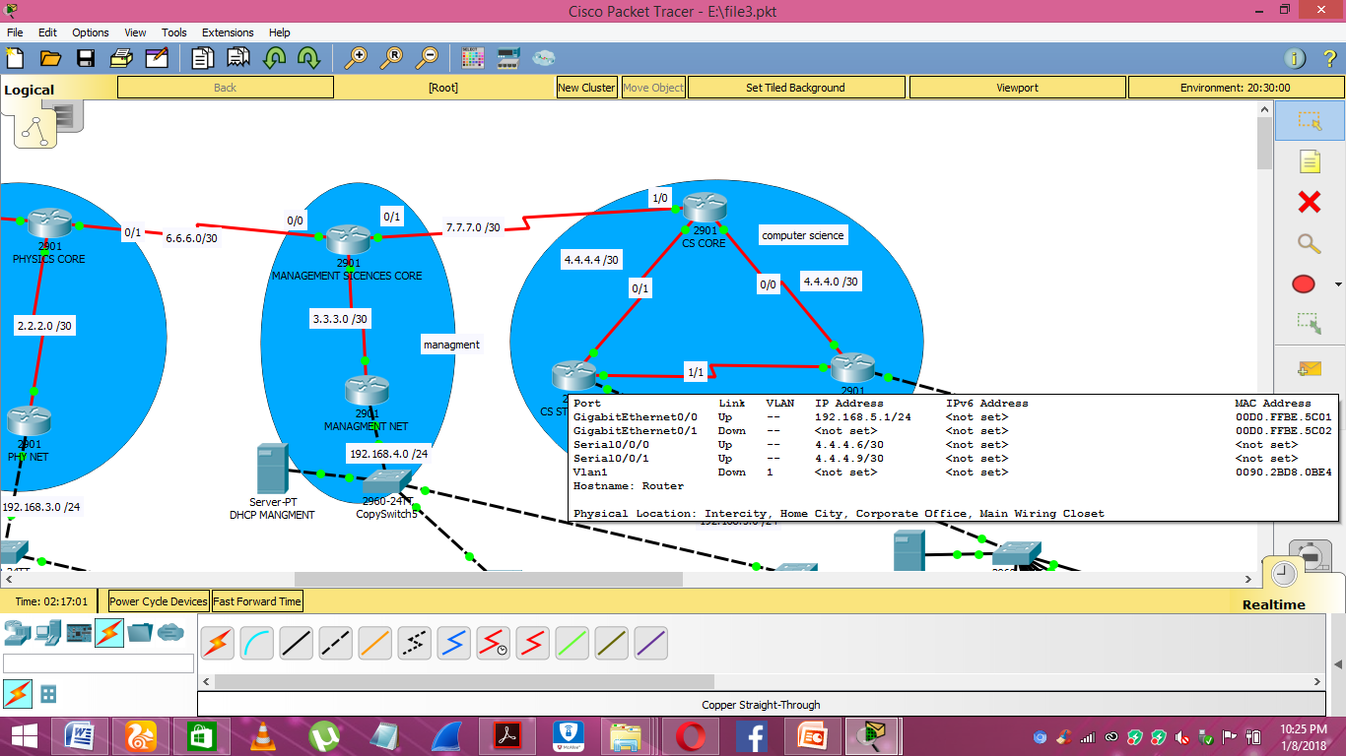

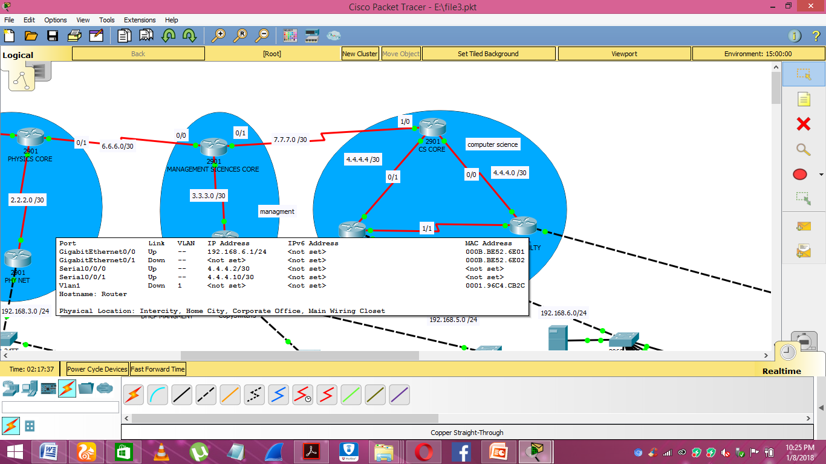

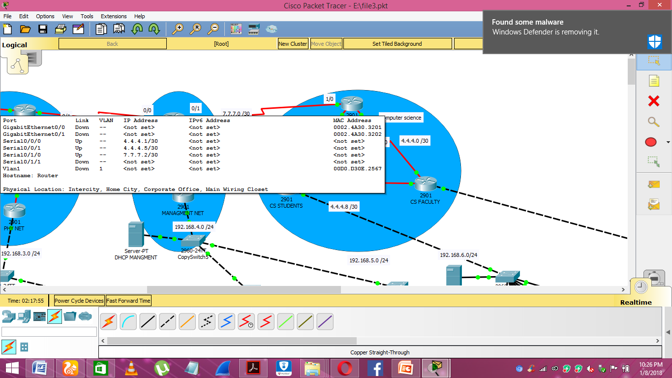

***Screenshots for each department Network (Total 4) :***

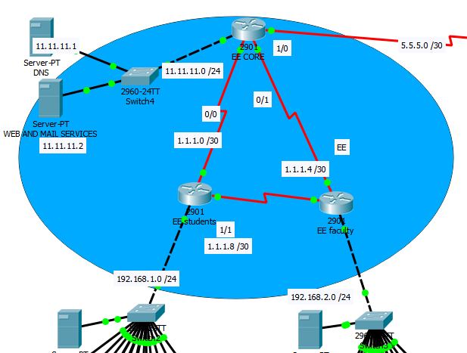

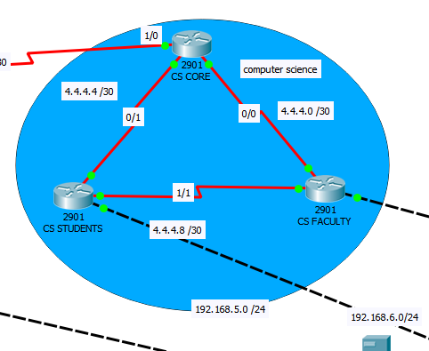

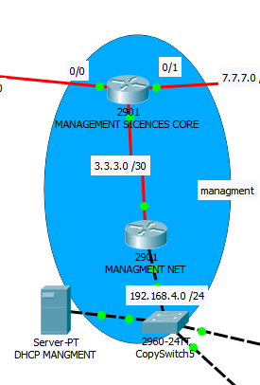



***Screenshots for department to department ping success (Total4) :***

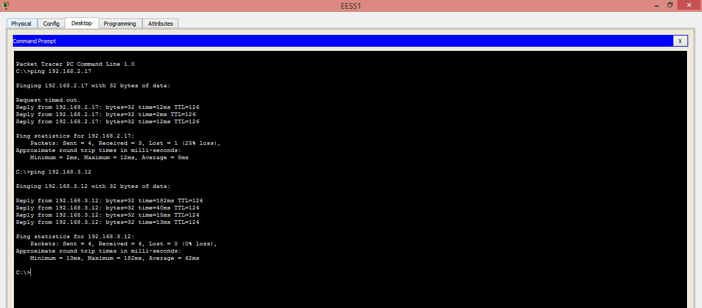

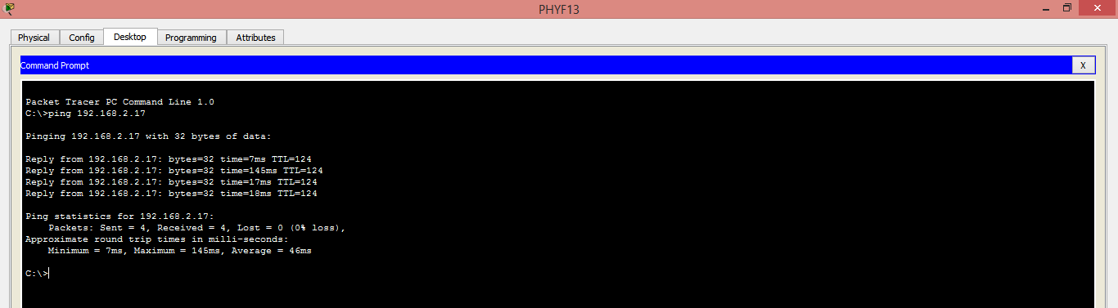

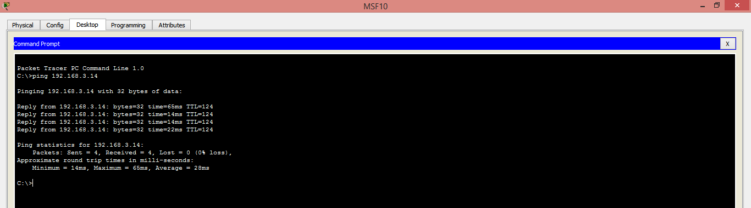

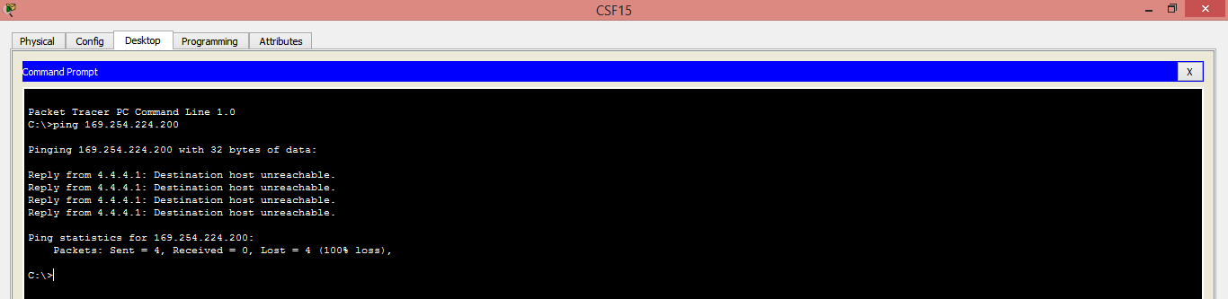

***Screenshots for accessing web server and mail server from each department (Total8) :***



